1. **Agenda**: How to log to external file.
2. **Benefits**: We can refer to the log later on. To persist the log for long time.
3. **Let’s make change to log42.xml file?**
4. We need to configure the RollingFileAppender (File can be rolled over every day with some new file name).
5. 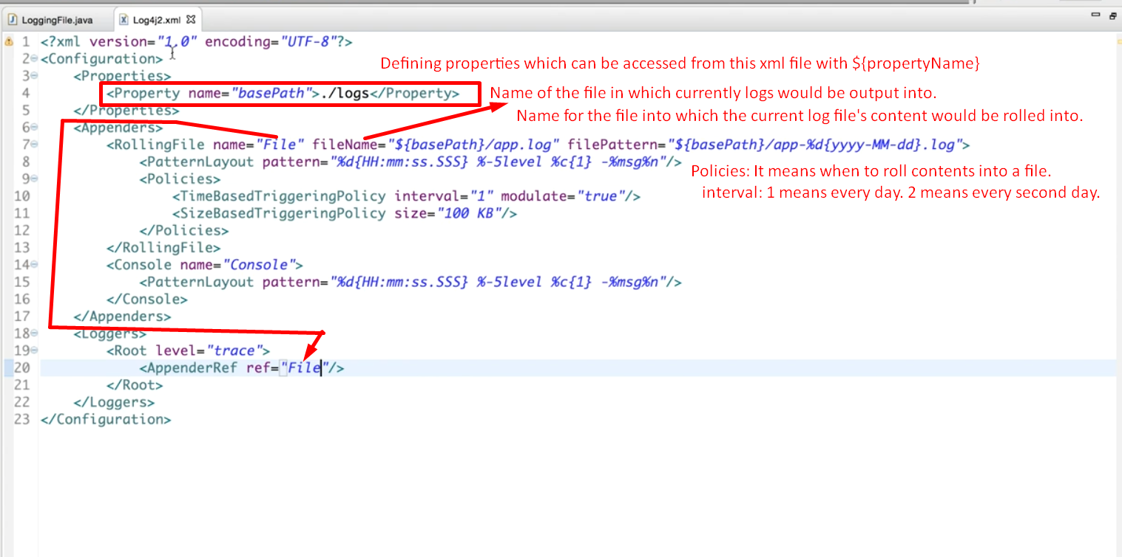
6. 